The ideas behind a subversion repository in a nutshell

The risk
Multiple parties, multiple data, multiple purposes easily results in a chaotic database. This can be done better. Currently :
- All collaborating, but not enough
- Coordination needed
- But no overall boss
- Like wikipedia
This is illustrated in Figure 1.

The solution
Optimal is possible with a subversion REPOSITORY (see Figure 2).

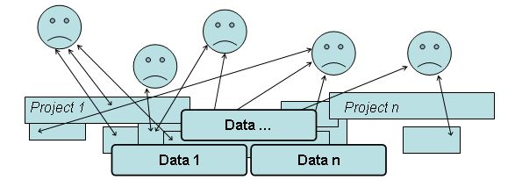 | 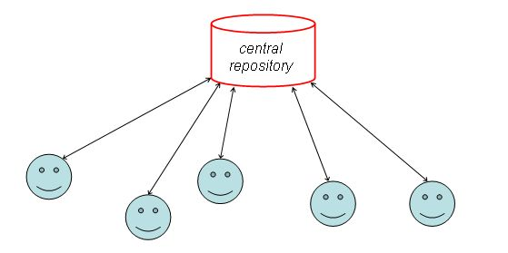
Figure 1. The risk: chaos | Figure 2. The solution: subversion repository

The principle:
Subversion repository basics:
- Get username and password, beause …
- for best quality, all actions are logged (see example below).
- nothing can be lost, only temporarily disabled
- so anyone can be allowed to join

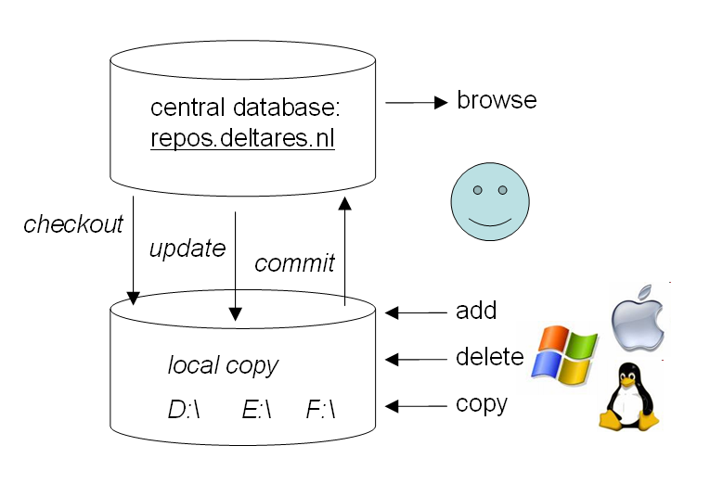
Figure 3. The principle

It is important to store all relevant data. Please note that Data = raw data + processing.

For example:
NASA satellite data with open source SeaDas processing toollkit (in IDL)
- L0: dump of recorded voltages, only averaged over 16 pixels
- L0: raw voltages
- L1: voltages + satellite track
- L2 ~ physical quantities
- L3 ~ binned in space (1 grid instead of zillions of warped photos)
- L4 ~ binned in time (climatology)

NASA only archives L0 data and the toolkit, that’s all they need to safeguard. L1 to L4 data products are regenerated regularly when new insights become available (like age deterioration of an instrument in only known a posteriori). These final L1 – L4 data products have a version number, due to which every single number can be traced back to an L0 voltage and a specific version number of the processing script. Data products without a version number are completely pointless. Data products are hosted on a web-server (OPeNDAP) for dissemination, but do not need to be archived in a repository.

A subversion repository: How does it work?
Deltares stelt een centraal 'repository' (uitwisselplatform en tevens archief) in waarin datasets voortschrijdend (d.w.z. in versies) kunnen worden beheerd (opgeslagen, benaderd, geupdate). Dit archief zal voor alle projectpartijen toegankelijk zijn: leesrechten voor de specifieke afnemers, schrijfrechten alleen voor de relevante partijen binnen het betreffende perceel. Uploads kunnen plaatsvinden zodra een partij zijn data kan en wil vrijgeven (na afronding van bepaalde campagne en QA, maar in ieder geval altijd voordat een volgende partij deze informatie nodig heeft). In de repository kunnen uiteraard naast de data files, ook gehele databases als werkdocumenten en afgeronde rapporten, wetenschappelijke papers en Powerpoint files opgeslagen en beheerd worden.

Structure of the repository
Here, we will illustrate the global structure of the repository. The structure was set-up for modifications in a.o. source code of Deltares software. Branches and Tags are specifically designed for such software developments and have no purpose for data management. We only work in the trunk.

Trunk
The trunk contains the main version of the data. This is where all (short) developments by all users take place. As we are only dealing with short developments this is where we work

Branches
Separate directory e.g. for code developments. Not used here.

Tags
Also for code developments. Not used here.

How? JUST DO IT
Now we will illustrate the use of SVN. We will illustrate this for the use on Windows, using TortoiseSVN. The process is that you obtain a local copy of (the part of) the repository, which we want to modify. As it is not handy to get files one by one with browser; get them all at once with free program (SVN tortoise). Installation instructions are described in Step 1 below.Step 2 describes how to make a local copy: a so called checkout. In Step 3 a description is given on how to edit the data in your local copy in such a way that SVN can keep track of the modifications. This can be done directly in the trunk. Step 4 describes how you can do an update which shows the difference between the local copy and the original version on the repository. Finally, step 6 describes the SVN commit functionality in which your modifications made in your local copy are fed to the repository on the server. From this moment all other repository members can benefit from your efforts.

At the end of this document a demonstration for the OpenEarthTools repository is given with screengrabs of the different steps described below.

Step 1: Download and install subversion (SVN)
SVN is a versioning tool. It can be used for keeping track of the history of practically anything. We use it a.o. for the data in the project tree. SVN is especially useful when multiple users work on the same data. SVN makes sure that the modifications made by one person are not overwritten by those of another person, even when they are modifying at the same time. On a server machine, a source code repository has been created, which can be accessed by everyone with an internet connection and admission to the repository.

For PMR NCV the repository is https://repos.deltares.nl/repos/PMR-NCV/

Several clients are available to make use of the SVN. The one most frequently used (at Deltares, on Windows) is TortoiseSVN. Other SVN clients are also available, especially for use on UNIX. The remainder of this memo will focus on the use of TortoiseSVN.

Download and installing TortoiseSVN
http://tortoisesvn.net → download → 32 bit (for most regular desktops).

Step 2: SVN Checkout: creating a local copy of (part of) the repository
First, we must obtain a local copy of the part of the directory, which we want to modify. We must therefore checkout that part of the trunk of the repository, which we are interested in. No need to back this up, it’s only a copy ...
Please note that the checkout also creates a shadow image locally on your pc. If you checkout 20Mb, you need 40 Mb of free disk space.

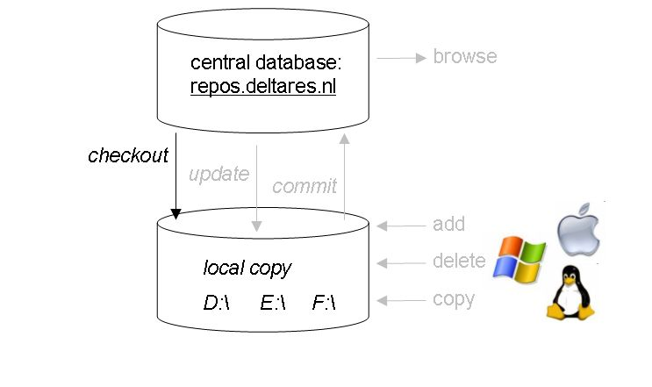
Figure 4 SVN checkout

Execute the following steps:
- Create a directory where you want to checkout the source code, e.g. E:\Checkouts\
- In this directory right click and select:
TortoiseSVN -> Checkout
or (when available in the right-click menu):
SVN Checkout
- In the Checkout window:
    - Specify the location of the source code in the repository.
For the data-trunk this is:
https://repos.deltares.nl/repos/PMR-NCV/trunk/
or on a sublevel:
https://repos.deltares.nl/repos/PMR-NCV/trunk/004 Abiotiek/
(Make sure that tree of local copy resembles the server)
    - Make sure the Checkout directory is the directory where you want your copy of the source code
    - Make sure the checkout depth is set to Fully recursive
    - Determine the revision, which you want to checkout. The HEAD revision is the newest version available. Using the Show log button you can search for other (older) revisions.
    - Click OK to checkout the source code to your local directory.

Note: once a checkout has been made in a certain directory it is not possible to create a second checkout in the same directory. You can now update your checkout to match the repository by following for example SVN Update (see description below in step 3)

Step 3: Making adjustments in the checkout: editing the data
Now you can modify the data. SVN will keep track of your changes locally on your PC. It stores information in subdirectories named “.svn”.
Important: modifying file or directory names of your local copy (checkout) requires special attention, see SVN rename. So does adding or removing files, see SVN Add/SVN delete. You can check whether the modifications are accepted by SVN by checking the icons of the particular file. A question mark means that the particular file is not registered with SVN. See “settings” under section “further information” below how to activate this functionality.

SVN rename
This is done by right-clicking the file and selecting:
TortoiseSVN -> Rename
SVN rename is different from a simple rename. It makes sure that SVN sees the old file (with a different name) as the predecessor of the new file (with the new name). It makes sure that with the next commit, the file is also renamed in the repository, such that when other users of the repository checkout the source code or update their local copy, the same file is also renamed in their version of the source code.
Simply renaming files causes SVN to loose track of the history of that file. If a file is renamed (not using SVN rename) SVN will think it is missing.

SVN add
This is done by right-clicking in the containing directory and selecting:
TortoiseSVN -> Add
Using SVN add you can add new files to the repository. The same holds here as for the SVN rename command. Simply adding a file by drag and drop in a certain directory will not do the trick. You must tell SVN that there is a new file for which it will have to keep track of its history. This is done using SVN add. The file will get a ‘+’ as Icon overlay (see Section Settings).

SVN delete
This is done by right-clicking in the containing directory and selecting:
TortoiseSVN -> Delete
For the SVN delete command the same restrictions hold as for SVN rename and SVN add. Simply deleting a file will not be enough for SVN. It will think the file is missing and put it back the next time you update. With an SVN delete you actually tell SVN to delete the file from its repository. Its history will be kept, but from this revision on the file will no longer be included in the source.
With an SVN delete the file will get an ‘x’ as Icon overlay (see Section Settings).

Step 4: SVN Update
Using SVN update you can merge the HEAD revision of the repository into your local copy. Always perform an SVN Update before committing your changes (Step 6: SVN Commit). Updating is done as follows:
- In the directory where you have your local copy of the source code, which you wish to update, right click and select:
  - TortoiseSVN -> Update
Or (when available in the right-click menu):
SVN Update
  - SVN will now search all files (recursively down from the directory where you are) in the repository that have been changed with respect to your local version.
  - SVN will merge these changes into the local version.
  - SVN will also detect whether one of the files you have edited, has also been edited by someone else. SVN will try to merge the changes. If SVN does not succeed, it will report a conflict that you have to resolve. See Resolving possible conflicts.

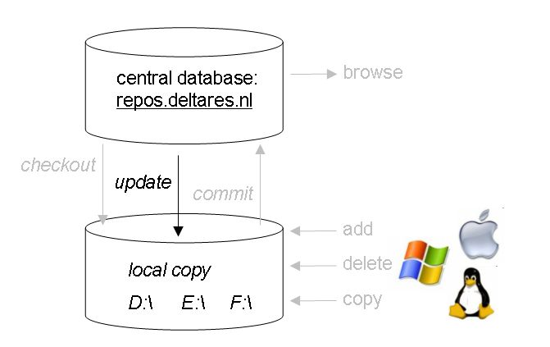
Figure 5 SVN update

Step 5: SVN Commit
Using SVN commit you can feed your modifications to the repository on the server. After a Commit, your modifications are available to everyone using the same repository. Be sure to always do an update before committing. This will avoid conflicts when SVN tries to merge your local copy with the repository version. Committing is done as follows:
- In the directory where you have the modified source code you wish to feed to the repository, right click and select:
  - TortoiseSVN -> Commit
Or (when available in the right-click menu):
SVN Commit
- SVN will now search all files (recursively down from the directory where you are) in the local version that you have changed and show them in a pop-up window. With check boxes, you can decide what changes have to be committed.
- You can add a message to describe your modification (please try to add a message always)
- When clicking OK, SVN sends your changes to the repository on the server machine and merges them.

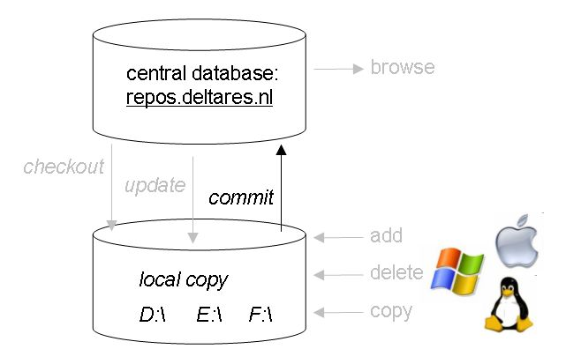
Figure 6 SVN commit

Additional SVN functionalities: browsing, logging, comparing etc

Repo-browser
This is done by right-clicking in the containing directory and selecting:
TortoiseSVN -> Repo-browser
The Repo-browser (Repository Browser) allows you to quickly browse through the repository. You can view the history (log) of the trunk and branches, you can search for certain revision numbers (top right) and you can checkout from the repository browser (by right-clicking).

Show log
This is done by right-clicking in the containing directory and selecting:
TortoiseSVN -> Show log
The log shows you the history of the source code. You can see which files have been modified, when the modifications were done, by whom and you can view possible comments that were added with the commit of that revision.

Comparing your local copy with the repository
Using SVN diff or Check for modifications you can investigate the status of your local copy, i.e. which files did you modify? Did you add/delete files? Are there any files, which have been modified in the repository (by other people) with respect to your local copy?

Resolving possible conflicts
When updating your source code or when committing to the repository, SVN will try to merge your local copy with its own version in the repository. Sometimes, when files have been edited by two different people in the same parts, SVN can not perform the merge. It will then yield conflicts. These must be resolved by hand. When finished resolving them, mark the related files as resolved via right click and select: TortoiseSVN -> Resolved.

Settings
When modifying a large number of files it can become difficult to keep an overview of which files you have edited. SVN has kept track of your modifications. Using Icon overlays you can easily detect which files have been modified, added, deleted or are in a conflicting state. The Icon overlays can be switched on as follows. In any directory, e.g. where you have your source code:

Right click and select TortoiseSVN -> Settings

In the Settings menu, select Icon overlays and make sure the checkbox Show overlays and context menu only in explorer is NOT checked (if you wish to see the overlays also in Total Commander).
Using Exclude paths and Include paths you can specify respectively which drives or directories SVN should not check or check explicitly. So if you do not want SVN to check your C: drive then write C: in the Exclude paths. If you however do want SVN to check the directory C:\source, then include C:\source in the Include paths.

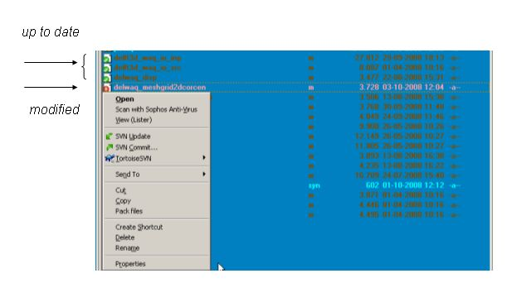
Figure 7 SVN example of icon overlays in Total Commander.

TIPS

- Maak checkout van alleen die subdirectories waar je iets mee doet (dus voor de meesten van ons niet op rootniveau in de directory-boom).
- Het is echter aan te bevelen wel de directory-structuur van de repository intact te houden op je locale schijf.
- Het is belangrijk aanpassingen in checkout middels SVN Rename, SVN Add and SVN Delete uit te voeren.
- Voer voor een commit altijd een update uit, zodat je aan kan vinken welke aanpassingen je wil committen naar de repository.
- It is important to commit your changes as often as possible (only the relevant stuff).

DEMONSTRATION
A demonstration is given for the “OpenEarthTools” repository.

- Step 2 (1). Make a checkout in e.g. E:\checkouts\
- Step 2 (2). In this directory right click and select: TortoiseSVN -> Checkout

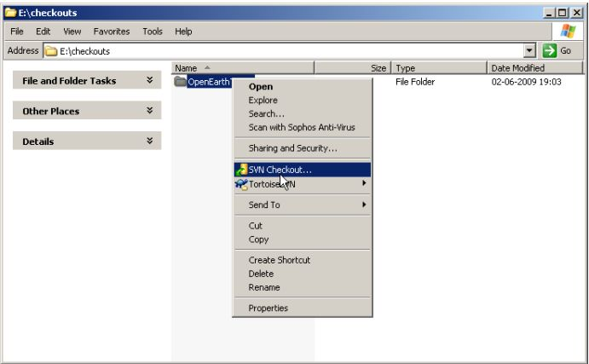
This demo is for the “OpenEarthTools” repository.

- Step 2 (3). Copy url from Internet browser (case sensitive!).

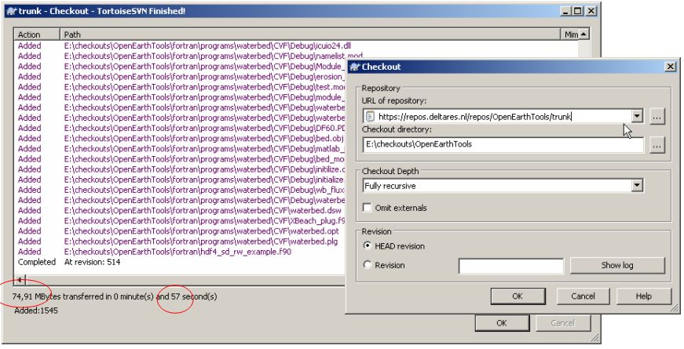

  - Step 3: check icons. Question marks mean that the modification is not registered with SVN.

  - Step 4: SVN Update
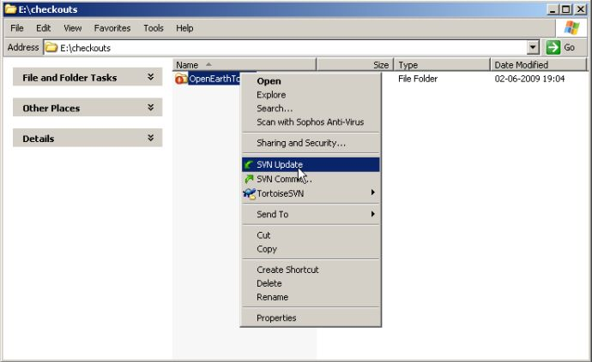

Result of the update: (show log)
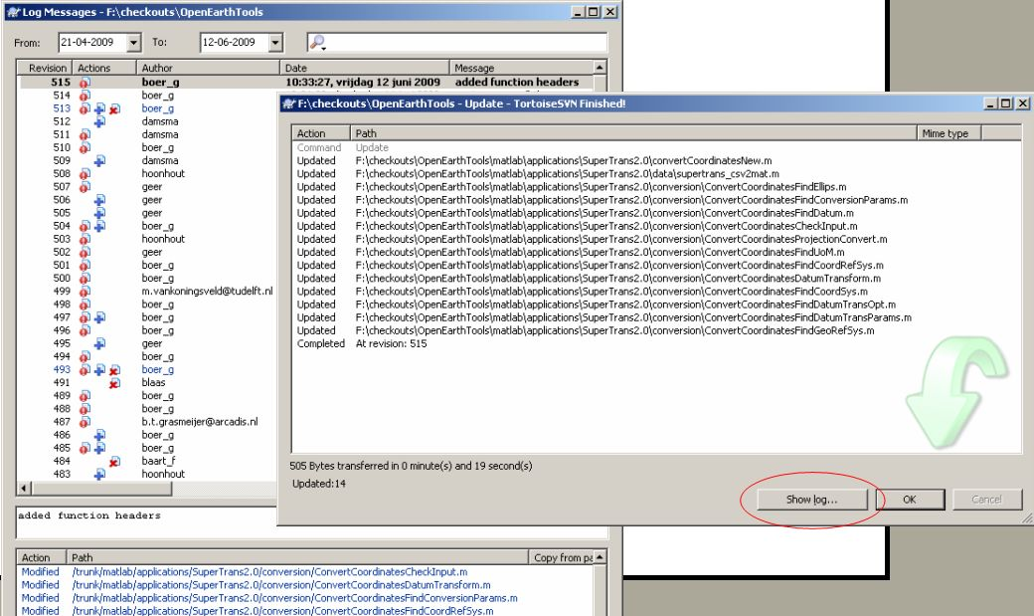

Every file is logged …
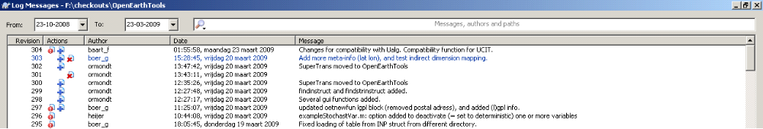

…. and every line is logged
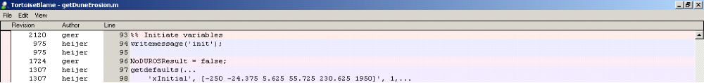

- Step 5: SVN commit….
Users ‘commit’ their files in one central database (regular update local copy). Every commit gets a unique revision number. Per commit one can add a comment to indicate what was changed. Please do add a line to describe what you did.

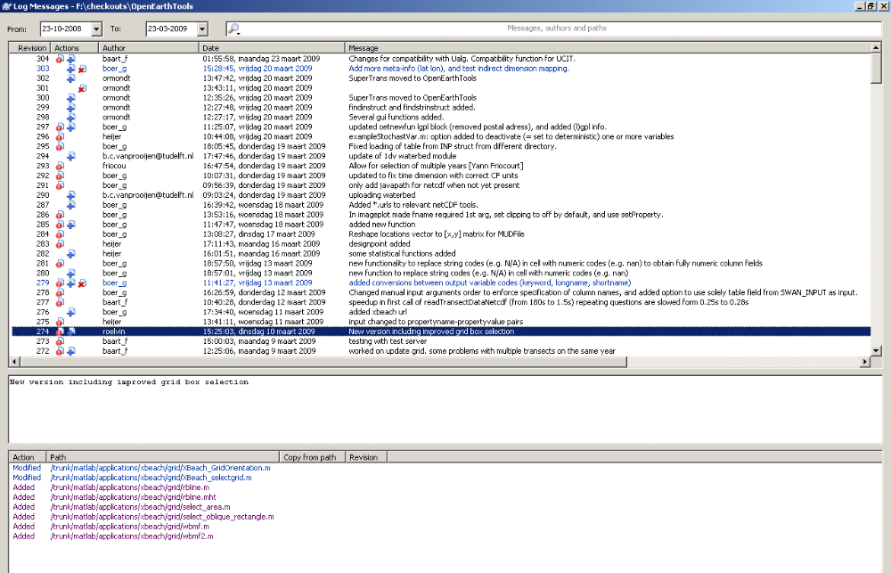
SVN commit: LOGGING

For every code line is it know who, when and under which revision number is was changed. Colors indicate the age of the code (more blue = older). Every change can be rolled back later on (a description on how to do this still needs to be added to this document).
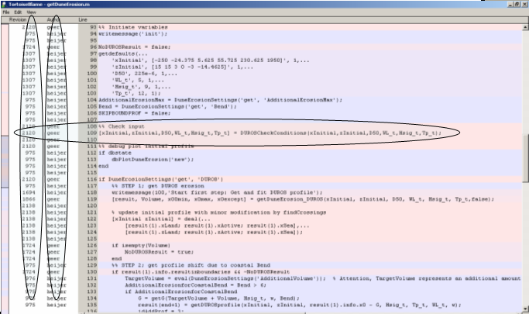
SVN commit: BLAMING

Het idee is dat wanneer aan een document of een dataset gewerkt wordt, deze asap (bijv aan het eind van de werkdag) weer terug op de repository wordt gezet zodat de efforts gedeeld en aangevuld kunnen worden met andere gebruikers. Het is echter niet de bedoeling om working documents en dataset zonder QA op de repository te zetten.

